**Project Design Phase-I**

**Solution Architecture**

|  |  |
| --- | --- |
| Date | 06 May 2023 |
| Team ID | NM2023TMID20436 |
| Project Name | Project - unleashing the potential of youth student performance analysis |

**Solution Architecture:**

Solution architecture is a complex process – with many sub-processes – that bridges the gap between business problems and technology solutions. Its goals are to:

* By integrating data analytics tools to an LMS educators and administrators can gain deeper insights to the student performance Overall LMS with data analytics capabilities can help educators and administrators make more informed decisions about student performance and improve outcome for all students .
* When communicating with the project stake holders about the software project it is clearly important to provide concise description of a structures ,characteristics, behaviour and other aspects of software.
* Feature: ability to track the student progress,analyze student performance data provide personalised feedback and generate reports.
* Development phases: planning, requirement gathering,design development testing and deployment
* Solution Requirements: Includes functional requirements such as ability to track student progress and generate reports as well as non -functional requirements like scalability ,security and useability .
* specifications according to which the solution is defined, managed, and delivered here requirements, technology stack ,architecture ,project management,testing,deployment,documentation.

**Example - Solution Architecture Diagram:**

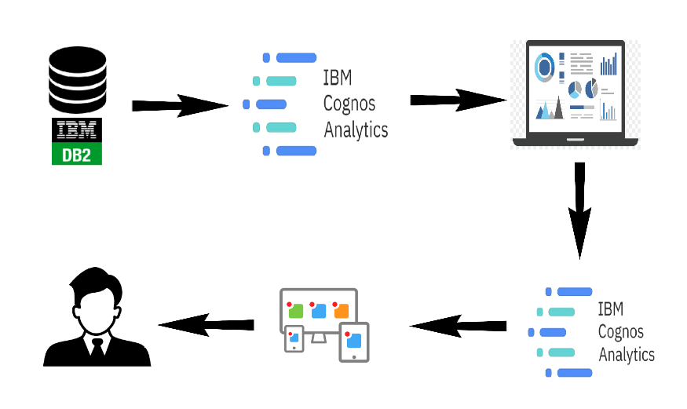

*Figure 1: Architecture and data flow of student performance analysis*

**Reference:**

**https://nmcareereducation.smartinternz.com/saas-guided-project/3/unleashing-the-potential-of-our-youth-a-student-performance-analysis**